

High Level Design & Low Level Design

Document Control :

Project Revision History
Date | Version | Author | Brief Description of Changes |  |  |  | Approve Sign
27.09.2022 | 1.0 | Group 6

Index
1. Introduction ------------------------------------------------ 4
1.1 Intended audience ------------------------------------------------ 4
1.2 Project purpose ------------------------------------------------ 4
1.3 Key project objective ------------------------------------------------ 5
1.4 Project scope and limitation ------------------------------------------------ 5
1.5 Functional overview ------------------------------------------------ 5
1.5.1Header files ------------------------------------------------ 5
1.5.2 Functions ------------------------------------------------ 5
2. Design overview ------------------------------------------------ 9
2.1 Design objective ------------------------------------------------ 9
2.2 Design alternative ------------------------------------------------ 9
2.3 User interface paradigms ------------------------------------------------ 9
2.4 Error detection/ Exceptional Handling ------------------------------------------------ 9
2.5 Performance ------------------------------------------------ 9
2.6 Maintenance ------------------------------------------------ 9
3.. Detailed system design -----------------------------------------------10
3.1 FlowChart -----------------------------------------------10
3.2 FlowChart of Report Corner ----------------------------------------------- 11
3.3DFD(Level 0) -----------------------------------------------12
3.3DFD(Level 1) -----------------------------------------------13

4. User Diagram - ----------------------------------------------14
4.1 Use Case Diagram -----------------------------------------------14
4.2 Sequence Diagram -----------------------------------------------15
4.3 Class Diagram -----------------------------------------------16
4.4 ER Diagram -----------------------------------------------16

5. Environment description ------------------------------------------------17
5.1 Time zone support ------------------------------------------------17 5.2 User desktop requirement ------------------------------------------------17
5.3 Server-side requirement ------------------------------------------------17
5.3.1Deployment consideration ----------------------------------------------- 17
5.3.2 Database server disk space ------------------------------------------------17
5.3.3 Integration requirements ------------------------------------------------17
5.4 Configuration ---------------------------------------------- 17
5.4.1 Operating System ------------------------------------------------17
6. Reference ------------------------------------------------18

Introduction: -

  - Intended Audience: -
There is no particular audience set for this project as anyone who wants to blood from blood donation system.

1.2 Project Purpose: -
The introduction of the software requirement specification provides an overview of the entire software. This is an overview description purpose, scope, tools used and basic description. The aim of this document is to gather, analyze and give an in-depth insight into the complete Online Blood Donation System by defining the problem statement in detail.
The detailed requirements of the Online Blood Donation System are provided in this document.

1.3 Key Project Objectives:
- Donor Registration
- Donor add details like their Aadharnumber,Name,Age,Address,Medical Clearence and Blood Group.
- Receiver Registration
- Receiver enters details like Aadharnumber,Name,Age,Address,Donor Aadhar Number and Blood Group.
- Employee logins with Name and password authentication.
- Employee here carry out the donation process from the donor database.
- Employee will generate the daily donation report accordingly.
- Employee will generate previous day report on demand along with 5 highest donor report.
- Employee make sure to empty the daily transaction file at the end of the day.

1.4 Project scope and limitation: -
Blood Donation Management System is a software application to build so that it should suit all types of blood banks in the future. One important scope is the availability of location-based blood bank details and extraction of location-based donor detail, which is very helpful to the people.
As far as limitation is concerned, there can be only one registration per benificiary in our project.
1.5 Functional Overview: -
1.5.1 Following header files are included in the program:
- #include <stdio.h>
- #include <ctype.h>
- #include <cppunit.hpp>
- #include <string.h>
- #include <pthread.h>
- #include <stdlib.h>
- #include <iostream>
- #include<header.hpp>
- #include <iomanip>
- #inlcude<bits/stdc++.h>
- #include<sstream>
- #inlcude<fstream>

    - Following functions are included in the program:
1.edit_donor_data() :-
Employee can edit all the donor details that are being entered by the donor at the time of the registration. The data that entered by the donor are mainly their aadhar number,Name,Age,Address,Blood Group and also their medical clearance from which the employee can update or edit the details like Name,Age,Address.

2.remove_donor_data() :-

By calling this function Employee can remove all the details entered by the donor at the time of registration.

3.view_donor_data() :-

By calling this function Employee can view all the details that are entered by donor at the time of registration.
4.previous_day_donor_report:() -
After Entering all the details of the donor in the donor database file the Employee generates a previous day report according to the date which contain all the informations of the donor who donated blood on previous day.
5. five_highest_donor_report() :-
After Entering all the details of the donor in the donor database file the Employee generates a Five highest donor report which contain the list of 5 highest donors who donated maximum unit of blood.
6.view_receiver_queue() :-
Here Employee can view all the details of the receivers who entered the system to receive the Blood.
7.carry_out_donation() :-
In Carry out donation all the donation process should be carried out by employee in the order of receiver’s registration and automatic updation of donor record and transaction file should be made after donation process.
8. remove_daily_transaction_file() :-
At the end of the day the employer is responsible for deleting the transaction file on the daily basis.
Blood Donation System comprises of the following modules:

Name of the Module | Donor Registration
Handled by | Snehal Bagul
Description | Donor enter his/her Valid Details and Unique Aadhar Number.

Name of the Module | Edit Donor Details
Handled by | Snehal Bagul
Description | Donor Records are updated or edited according to the conditions.

Name of the Module | Remove Donor Details
Handled by | Nidhi Dubey
Description | Donor Records are removed or deleted according to the conditions.

Name of the Module | View Donor Details
Handled by | Nidhi Dubey
Description | All Donor Records are viewed or displayed.

Name of the Module | Receiver Registration
Handled by | Muskan Yadav
Description | Receiver enters his/her Valid Details to register to the system and get the blood unit required.

Name of the Module | Receiver Queue
Handled by | Muskan Yadav
Description | The Employee stores the record of all the receivers in form of Queue.

Name of the Module | Employee Registration by Name
Handled by | Dolly Saluja
Description | Employee registers a valid name when asked by the system.

Name of the Module | Employee Password Authentication
Handled by | Dolly Saluja
Description | Only the employee with specific name and a valid password can enter ,do the relevant changes and the view the reports.

Name of the Module | Daily Donation Report
Handled by | Dolly Saluja,Muskan Yadav
Description | Report is generated which stores the the information of the donors on the daily basis.

Name of the Module | 5 Highest Donor Report
Handled by | Snehal Girish Bagul,Nidhi Dubey
Description | The Employee generates a Five highest donor report which contain the list of 5 highest donors who donated maximum unit of blood.

Name of the Module | Previous Day Donation Report
Handled by | Dolly Saluja,Muskan Yadav
Description | Employee Generates a previous day report which  contains the information or data about the donors that have donated blood on one day before.

Name of the Module | Carry Out Donation
Handled by | Nidhi Dubey,Snehal Bagul
Description | All the donation process should be carried out by the employee in the order of receiver’s registration and automatic updation of donor record and transaction file should be made after donation process.

Design Objectives: -
- Donor Registration
- Edit Donor Details
- Delete/Remove Donor Details
- View Donor Details
- Receiver’s Registration
- Receiver Queue
- Employee Login with password
- Carry Out Donation
- Daily Donation Report
- 5 Highest Donor Report
- Previous Day Donation Report

  - Design Alternative: -
we have used mostly the C++ concepts to perform all the relevant operations in the particular files .

2.3 User Interface Paradigms: -
The Online Blood Donation System, gives a donor an option to register themselfs and store all the data in Donor Database system file. A system always works faster than a person can. s given Employee act as an interface to add a new record in case he wants to add a record, an option to remove a record,view a record with various options, update a record.

Error Detection / Exceptional Handling: -
- User should first enter the details according the condition and if the entered detail is not according the condition specified sometimes it is displays the message that is entered and sometimes it returns with an error.

Performance: -
The performance depends up on the hardware component and cloud working of the user’s system.

Maintenance: -
Very little maintenance should be required for this setup. An initial configuration will be the only system required interaction after system is put together. The only other user maintenance would be any changes to settings after setup, and any specified special cases where user settings or history need to be changed. Physical maintenance on the system’s parts may be required, and would result in temporary loss of data or Internet. Upgrades of hardware and software should have little effect on this project but may result in downtime.
3 DETAILED SYSTEM DESIGN

3.1 FlowChart
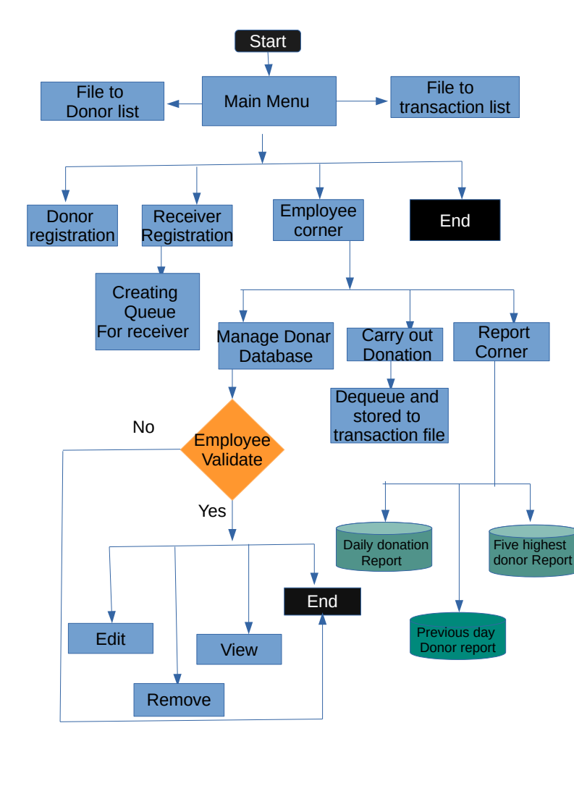

3.2.FlowChart of Report Corner
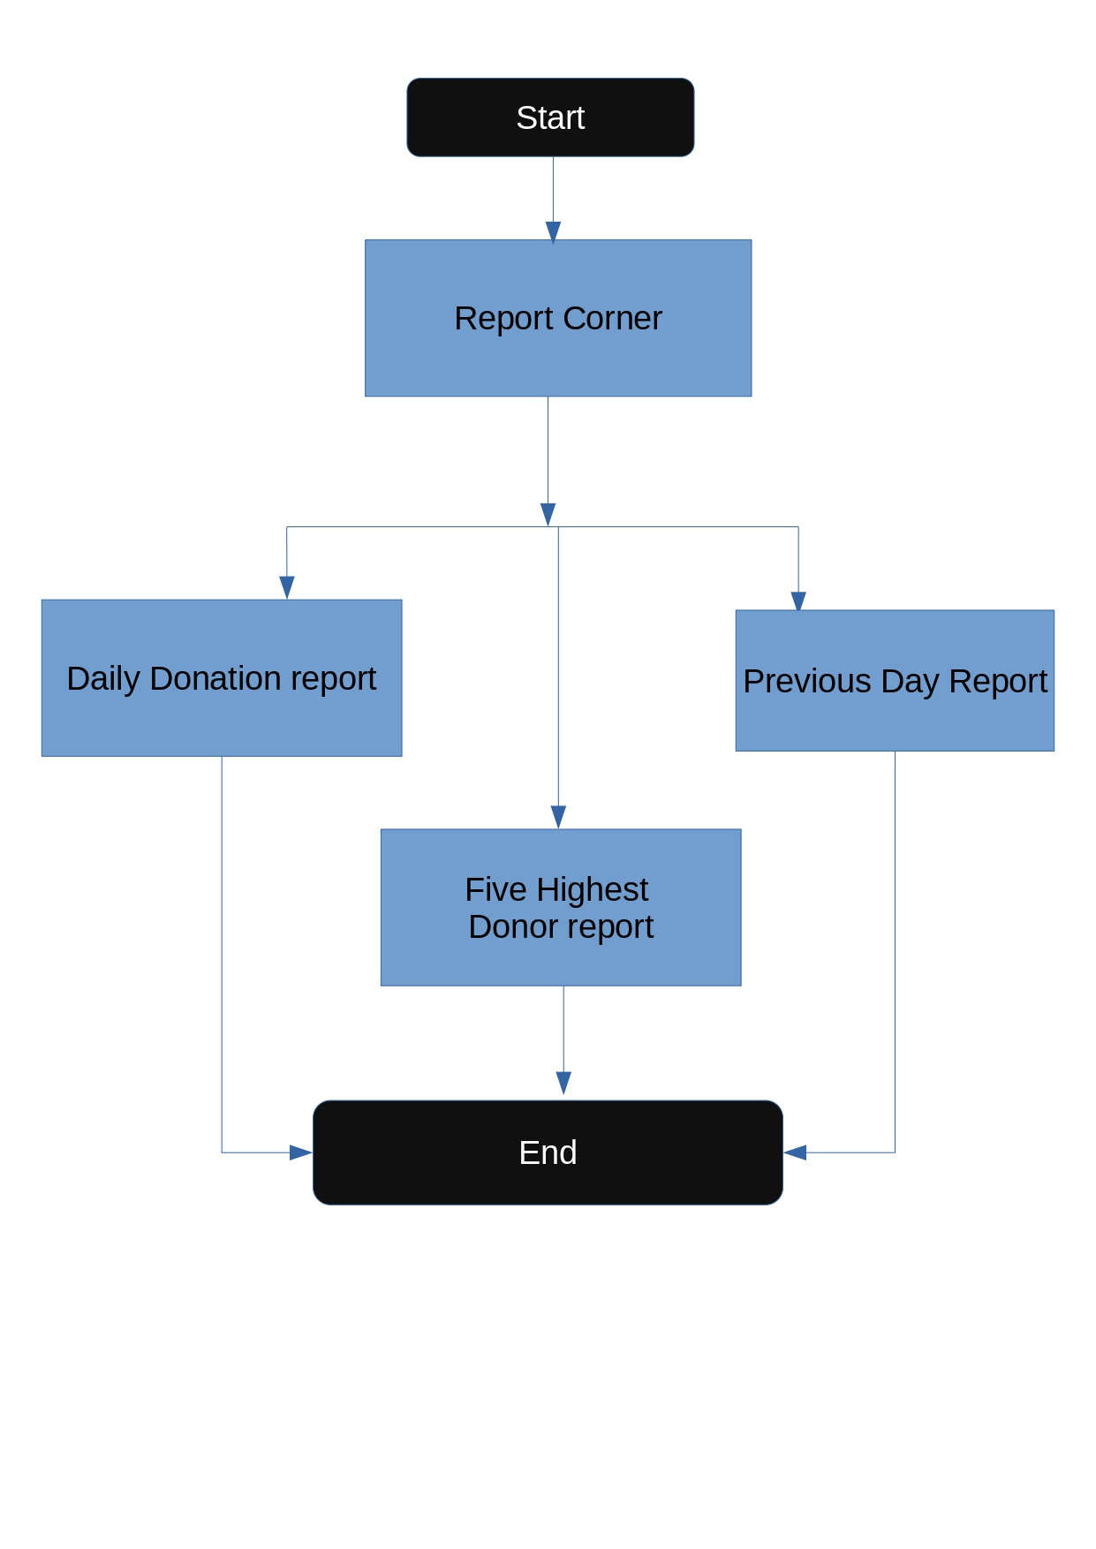

3.3 DFD (Level 0)
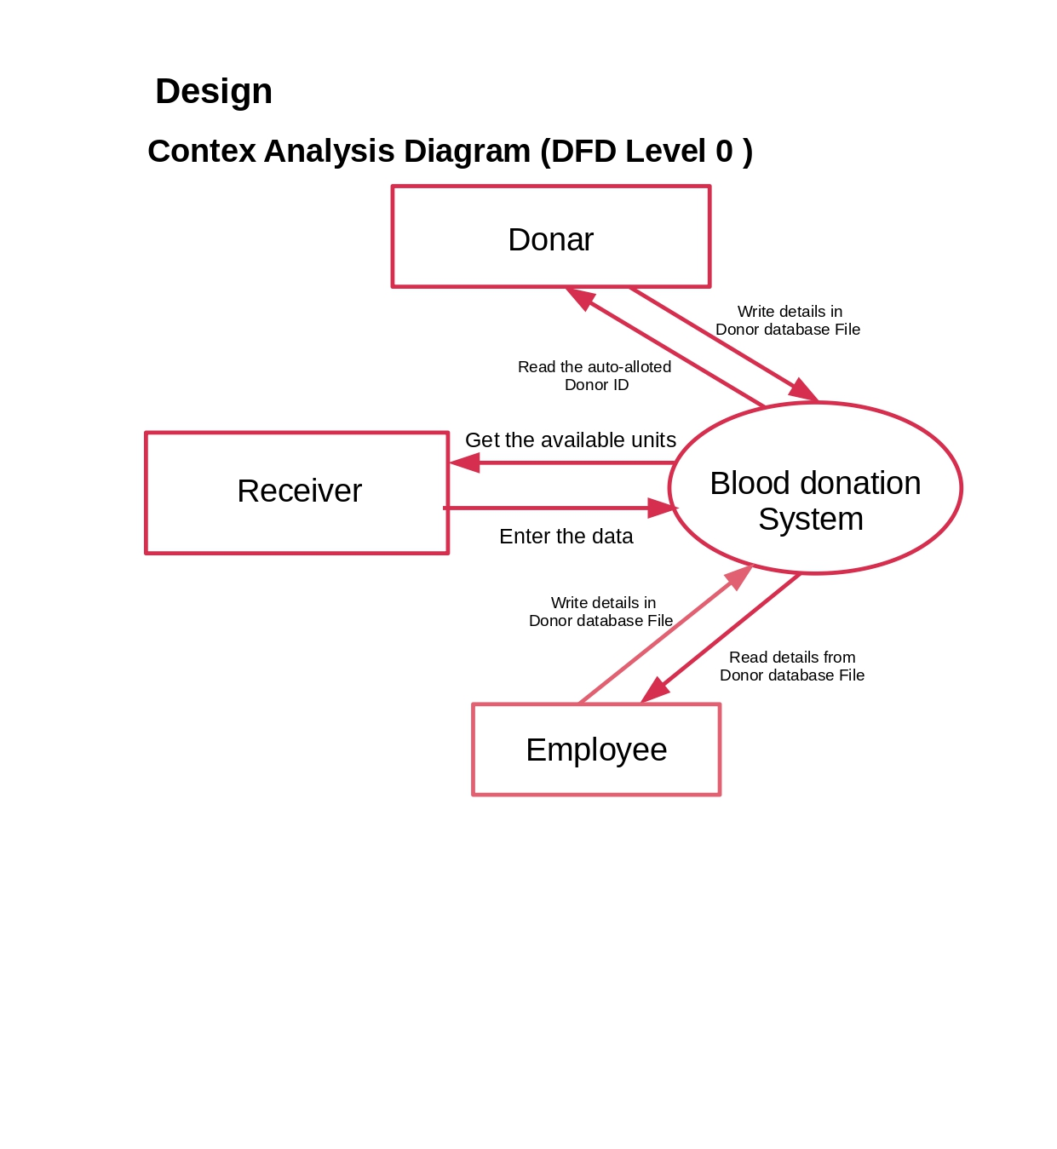

3.4 DFD(Level 1)
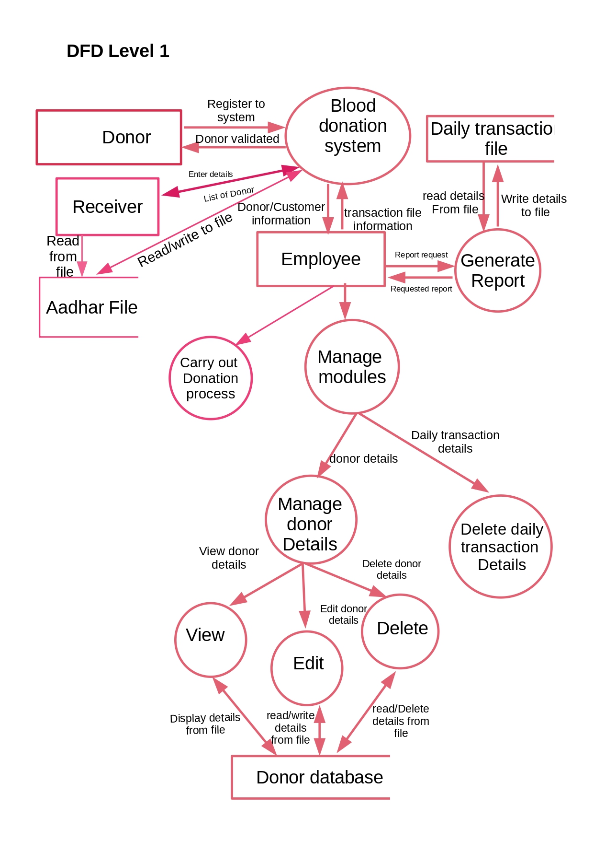

4. UML Diagram(Unified Modifying Language)
4.1 Use Case Diagram
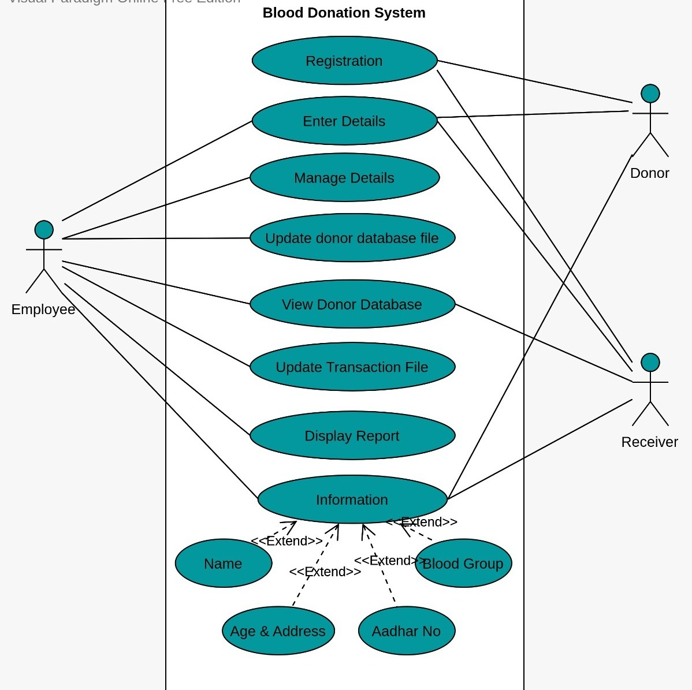

4.2 Sequence Diagram
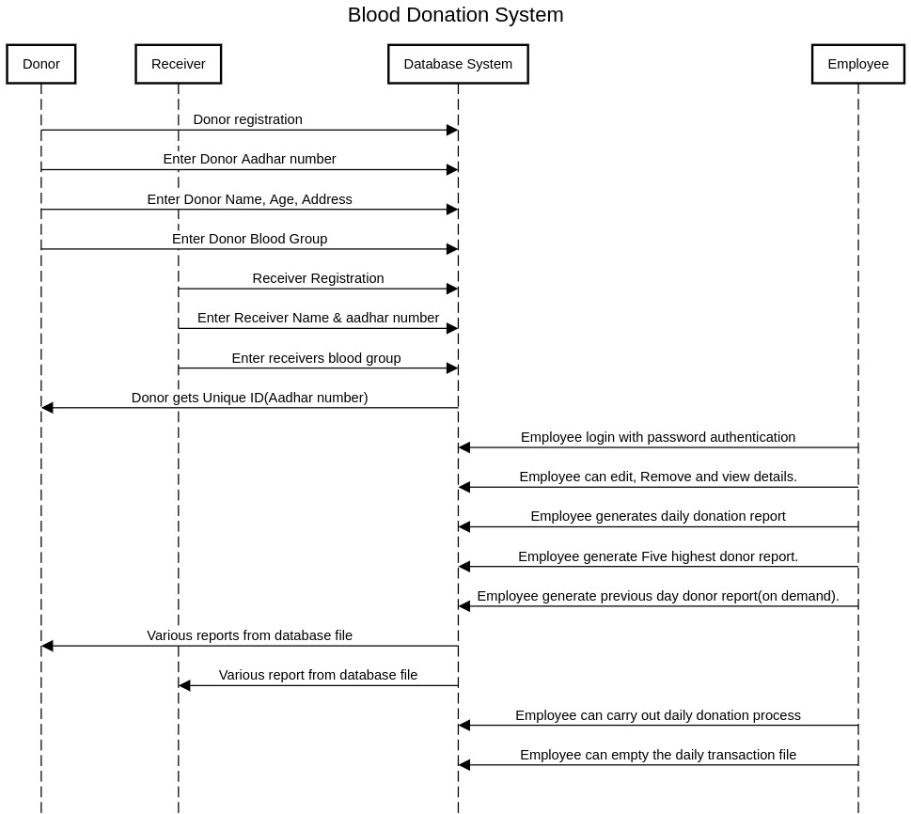

4.3 Class Diagram
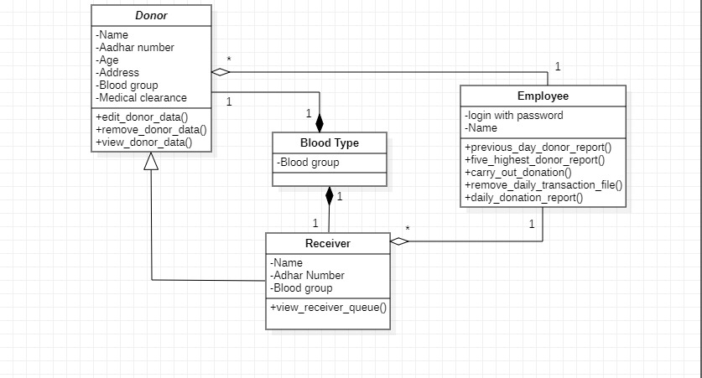
4.4 ER Diagram
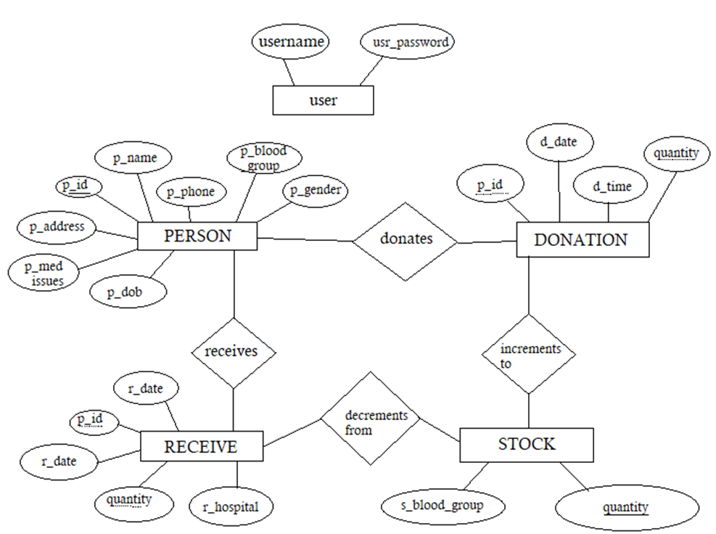
Environment Description: -
5.1 Time Zone Support: - IST
5.2User Desktop Requirements: -
a. 64-bit processor, 1 GHz or faster
b. At least 2 GB free hard drive space
c. At least 1 GB RAM
5.3Server-Side Requirements: -
- 32 64-bit processor, 1 GHz or faster
- At least 1 GB free hard drive space
- At least 1GB RAM
5.3.1. Deployment Considerations: -
  - Easy setup: no session storage daemon, use tmpfs and memory caching to enhance performance.
  - Local storage is used
  - No network latency to consider
  - To scale buy a bigger CPU, more memory, larger hard drive, or additional hardware
Application Server Disk Space: -
No such disk space is required as the program is fully functional on online
IDE(s) as well. Local Operating System is required and one txt file to store the
records of processes.
5.3.2 Database Server Disk Space: -
No such disk space is required as the program is fully functional on online
IDE(s) as well.
5.3.3 Integration Requirements: -
a. Language: - C
b. Tools: - Gcov, Valgrind, Makefile ,Cunit
c. Complier: - g++
d. Linux Environment
5.4 Configuration: -
5.4.1. Operating System: - Linux environment

6. Reference: -
https://www.lucidchart.com/blog/types-of-UML-diagrams
https://github.com/SurajSubramanian/Blood-Donation-System/blob/master/blood_donation_system.cpp
https://www.edrawsoft.com/uml/create-uml-class-diagram.html
https://www.nhs.uk/conditions/blood-groups.com
https://www.blood.co.uk/why-give-blood/blood-types.com
https://www.ncbi.nlm.nih.gov/books/NBK525967.com

